18.1.1 Editors - Drivers Editor - Header tools and options
Introduction 1
Header Tabs 1
Use Normalization , Create Ghost Curves 1
Use Normalization 2
Auto Normalization 2
Create Ghost Curves 2
Filters 2
Only Show Selected 2
Show Hidden 2
Only Show Errors 2
Filtering Collection 2
Filter by Type 2
Options 3
Sort Data Blocks 3
Auto Snap 3
Proportional Editing 3
Easing Mode, Keyframe Handle Type, Keyframe Interpolation, Keyframe Type 3
Easing Mode 3
Last Operator Set Keyframe Easing Type 3
Type 3
Keyframe Handle Type 4
Last Operator Set Keyframe Handle Type 4
Type 4
Keyframe Interpolation Mode 4
Last Operator Set Keyframe Interpolation 4
Type 4
Keyframe Type 4

Introduction

The header contains various menus and tools. This chapter here is about the tools, modes and options elements in the header.

The text menus are covered in a own chapter each. They vary too much, dependant of mode and object type.

Header Tabs

The tabs at the very left allows you to switch between the four most important editor types by one click. Dopesheet Editor, Graph Editor, Driver Editor, NLA Editor.

Use Normalization , Create Ghost Curves

Use Normalization
Normalizes the curves so that the maximum does not exceed 1 and the minimum does not go lower than -1

Auto Normalization
Automatically recalculate curve normalization when you modify the curve.

Create Ghost Curves
Creates a snapshot of the current curves, and displays it as a background image in the viewport. This background image is not permanent, and will be deleted when you close Bforartists.
When a ghost backgroud image is created then the button turns into a delete button with which you can remove the ghost image.

Filters
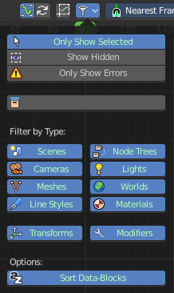
The Filters panel allows you to filter out elements.
Note that in other modes the panel does not show all content. In Action Editor mode for example it just shows the first four elements.

Only Show Selected
Display only the data for the selected object in the list of elements. If off it displays all available animation data of the whole scene.

Show Hidden
Include channels from objects / bones that are not visible. This feature just works with Only Selected off.

Only Show Errors
Only display F-Curves and Drivers that have errors or are disabled.

Filtering Collection
Just display the content from the chosen collection in the list of elements.

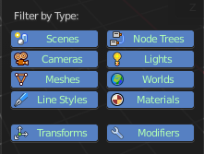
Filter by Type
In this section you can choose what type of animation data should be displayed. The names should be self explaining.

Options

Sort Data Blocks
Alphabetically sort the data in the list of elements.

Auto Snap

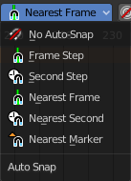
Adjust how the selected keyframe or fcurve point snaps to other elements.

Proportional Editing

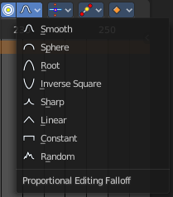
Enable proportional editing.

Proportional editing allows you for example to scale two keyframes and influence the not selected neighbour keyframes in a proportional way. Or the proportional editing of fcurve points.

The dropdown menu to choose the proportional editing falloff method is just available when the proportional tool is active.

Easing Mode, Keyframe Handle Type, Keyframe Interpolation, Keyframe Type

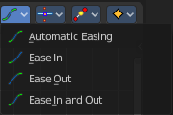
Easing Mode
The easing methods in the interpolation mode menü are for the easing shape. This menu allows you to choose a easing method.

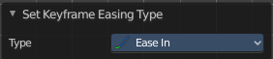
Last Operator Set Keyframe Easing Type

Type
Set the easing type.

Keyframe Handle Type
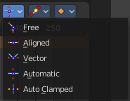
Set the handle type for the currently selected keyframes.
This is a feature for the Graph editor, where each curve point has its own handler with which you can influence the curve behaviour. But the handler type also influences how the animation curve acts at the chosen keyframes. So it has its use in the dopesheet editor too.
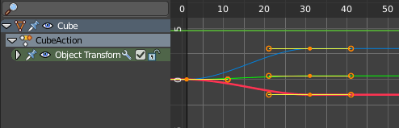

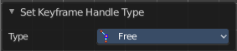
Last Operator Set Keyframe Handle Type

Type
Set the handle type for the currently selected curve point.

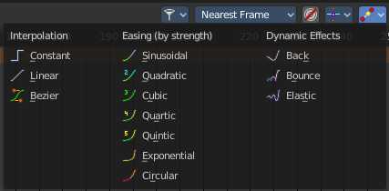
Keyframe Interpolation Mode
The Interpolation mode defines how the curve acts from keyframe to keyframe. You can have a linear curve between two keyframes instead of a bent one for example.
The easing methods here in the interpolation mode menU are for the easing shape. There is also a easing menu where you can choose a easing method.

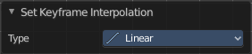
Last Operator Set Keyframe Interpolation

Type
Set the interpolation mode.

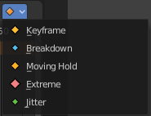
Keyframe Type
Recolor the currently selected keyframes. Or create the next keyframe with this chosen keyframe color.
This menu has no use in the Driver editor. It is a Dope Sheet editor toolset.

